Car modification shopping system

A CSCI 313 project

Table of Contents

1.Introduction4

1.1Abstract………………………………………………………………………………………………….4

1.2 Project Idea …………………………………………………………………………………………...4

1.3 Problem Statement…………………………………………………………………………………...5

‎1.4 User Personas………………………………………………………………………………………...5

‎**2. Overall Description………………………………………………………………………….9**

‎2.1 Purpose‎....................................................................................................................................................9

2.2 Scope of the project.10

2.3 Technologies Used...10

2.4 Intended Audience.10

2.5 Overview of the document.11

**3. Functional Requirements............................................................................11**

3.1 Class User (Student)………………………………………………………………………….11

3.1.1 Title: Course Enrolment Management…………………………………………………….12

3.1.2 Title: User Registration and Login……………………………………………………....12

3.1.3 Title: Course Progress Tracking………………………………………………………......10

3.1.4 Title: Reviews and Ratings………………………………………………………….........10

3.2 Class Course………………………………………………………………………..........…10

3.2.1 Title: Pricing Management………………………………………………………...........…10

3.2.2 Title: Course Availability and Enrolment…………………………………………............11

3.3 Class Instructor………………………………………………………..............11

3.3.1 Title: Authentication Process………………………………………............11

3.3.2 Title: Course Content Management…………………………………………...........……11

3.4 Class Admin…………………………………………………………………......................12

3.4.1 Title: Platform Monitoring and Content Moderation……………………………………12

3.4.2 Title: Revenue and Analytics Tracking.............................................................................13

**4.Non-Functional Requirements.........................................................................14**

4.1 Reliability............................................................................................................................14

4.2 Recoverability...................................................................................................................14

4.3 Performance........................................................................................................................14

4.4 Availability..........................................................................................................................14

4.5 Usability...............................................................................................................................15

4.6 Maintainability.....................................................................................................................15

**5. Diagrams .......................................................................................................... 16**

5.1. Use case Diagram .......................................................................................................... 16

5.1.1. Use case scenarios................................................................................................ 17

5.2. Sequence Diagram ......................................................................................................... 26

5.3 Class Diagram..................................................................................................................27

**Objective: Build Car modification shopping website that functions similarly to Amazon.**

**1. Introduction**

## **1.1 Abstract**

CarModShop is an e-commerce platform developed to enhance the car-modification shopping experience by providing an accessible marketplace for enthusiasts to reserve products and accessories. The website allows users to create personal accounts, securely browse and reserve a select range of car modification parts, and gain access to detailed product descriptions and reviews. Each product includes interactive features such as customer ratings and installation assistance at our onsite workshop, helping users make informed purchasing decisions. Built with a Django backend and PostgreSQL database, CarModShop offers a smooth and secure shopping experience, empowering car enthusiasts to enhance their vehicles with ease and security.

## **1.2 Project Idea**

Develop an Online Car Modification Shopping Platform that allows car enthusiasts to create accounts, browse and reserve a select range of modification parts, and access detailed product information. The platform will leverage Django for its backend and offer a user-friendly interface. It will integrate features like order reserving, personalized product recommendations, and user management for both customers and admin.

**1.3 Problem Statement**

Building a car modification shopping website addresses the global challenge faced by car enthusiasts in accessing affordable, reliable, and high-quality car parts. While many auto shops offer parts, they often lack features that help users identify which parts are compatible with their vehicles. Additionally, many shops do not provide a website so potential customers are unable to see these shop’s inventory and location, allowing customers to reserve parts and be sent to the shop for installation or pickup, and help inexperienced customers with their decision-making process. Furthermore, there aren’t many websites that specialize in our service, especially in our country, hence this website will be a pioneer for the car modding industry.

## **1.4 User Personas**

### Persona 1: Ahmed, the Car Enthusiast

Demographics:

- Age: 29

- Gender: Male

- Occupation: Engineer

- Location: Cairo, Egypt

- Income: Middle to Upper-middle class

- Lifestyle: Tech-savvy, spends weekends on car-related activities.

Goals:

- Upgrade his car’s performance and appearance regularly to stay trendy.

- Source high-quality spare parts easily without visiting multiple shops.

- Learn about the latest car trends and customization options.

Pain Points:

- Struggles with finding reliable, genuine spare parts in local markets.

- Inconvenience of visiting multiple shops to compare prices and availability.

- Lack of detailed product descriptions and customer reviews in offline stores.

Behaviors:

- Frequently searches online for car modification ideas and part reviews.

- Active in car enthusiast communities on social media platforms.

Gains:

- Provides a wide variety of genuine spare parts with detailed descriptions.

- Includes customer reviews and product ratings to ensure reliability.

- Offers exclusive deals on trendy parts.

Wish List:

- A platform with a "Build My Car" feature to visualize potential upgrades.

- Notifications about the latest car trends and new spare part arrivals.

- Customized recommendations based on his car model and preferences.

- Tutorials or guides for installing parts independently.

### Persona 2: Mona, the Trendy Driver

Demographics:

- Age: 35

- Gender: Female

- Occupation: Marketing Manager

- Location: Alexandria, Egypt

- Income: Upper-middle class

- Lifestyle: Fashion-forward, enjoys keeping her possessions, including her car, stylish and up-to-date.

Goals:

- Maintain her car in excellent condition to match her stylish personality.

- Add trendy accessories and features that enhance the car’s aesthetics.

- Save time while ensuring quality when buying car parts and accessories.

Pain Points:

- Limited knowledge about technical car parts and difficulty in finding trustworthy guidance.

- Concerned about overpaying for subpar products at physical stores.

- Lack of access to trendy, high-quality car accessories in her area.

Behaviors:

- Looks for personalized suggestions and trending products online.

- Values convenience and efficiency over price but still appreciates discounts.

- Occasionally participates in car-related events or lifestyle expos.

Gains:

- Features a user-friendly interface that suggests trendy car accessories and customizations.

- Provides educational content and recommendations for non-experts.

- Offers an option to connect with experts for advice on the best parts for her car.

Wish List:

- A feature to virtually try out accessories and see how they would look on her car.

- Personalized notifications for deals on accessories for her car model.

- A loyalty program that rewards frequent purchases with discounts or free gifts.

- Availability of package deals, such as "Seasonal Car Makeover" kits.

**2. Overall Description**

## **2.1 Purpose**

The purpose of this e-commerce project is to aid car fans on how to tune their cars without the hassle of searching. This platform enables customers to search for their desired parts and reserve them and allows the customer to have the parts installed in his car. The system reduces manual effort by allowing the customer to skip the hassle of searching for parts in different shops then comparing the prices only to have to transport the parts to a different person to install it, our system does all that allowing the user to modify his car to his heart’s desire without any of the physical hassle associated with it.

## **2.2 Scope**

This e-commerce platform project focuses on simplifying the way customers get and install their parts. customers can search for parts, compare prices, reserve items for installation, and have said parts installed for them. The platform provides features such as a review system, personal recommendations, and analytics dashboards. This project benefits the modding industry by simplifying the way customers search and purchase parts for their cars.

## **2.3 Technologies Used**

* **Programming Language:** JavaScript for frontend
* **Frontend Framework:** React.js
* **Backend Framework:** Node.js Django
* **Database Management:** MySQL
* **Other Tools:** GitHub for version control

## **2.4 Intended Audience**

* **Car Enthusiasts (Customers)**: The primary audience for the platform. These users are passionate about modifying their vehicles and seek an easy, efficient way to find quality car parts, accessories, and modification tools. They may have varying levels of knowledge, from beginners to experienced modifiers. The platform should cater to their needs by providing product recommendations, compatibility guides, and detailed descriptions that help users make informed decisions.
* **Automobile Hobbyists (DIYers)**: These users enjoy customizing their cars on their own. They look for detailed product information, compatibility with their specific vehicle models, and instructional content to guide them through the modification process.
* **Car Restoration Specialists and Professionals**: A segment of our audience may include professionals in the car modification and restoration industry who need reliable access to high-quality parts and supplies. They require an efficient way to order parts in bulk, ensure compatibility with multiple vehicle types, and may value features like trade discounts or bulk pricing.

## **2.5 Overview**

This project results in a modern, scalable car modification shopping platform. Car enthusiasts benefit from an intuitive interface that simplifies the search for compatible parts and accessories, allowing them to focus on their projects. Customers experience a streamlined shopping journey with features like personalized recommendations, detailed product descriptions, and user reviews. The platform fosters a seamless and engaging shopping experience that enhances user satisfaction and supports the car modification community in sharing knowledge and expertise.

**3. Functional Requirements**

## **3.1 Class User (Customer):**

### **3.1.1 Title: User Registration and Login**

**• Description: Users should be able to register, log in, and manage their account securely.**

**• Required Information:**

**o Email**

**o Password**

### **3.1.2 Title: Profile Management**

**• Description: Users should be able to update their profile information, including name and password, for account customization.**

**• Required Information:**

**o Name**

**o Password**

### **3.1.3 Title: Vehicle Management**

**Description: Users can register and manage their vehicles by entering details such as make, model, and year, ensuring the website provides compatible part recommendations.**

**Required Information:**

* **Vehicle make**
* **Vehicle model**
* **Vehicle year**

### **3.1.4 Title: Modification Request Management**

**• Description: Users should be able to create and track modification requests for their vehicles, such as part replacements or customizations.**

**Required Information:**

* **Desired modification**
* **Vehicle details**
* **Request status**

## **3.2 Class Vehicle:**

### **3.2.1 Title: View Vehicle Details**

**• Description: Users can view the list of all registered vehicles and their associated details.**

**• Required Information:**

* **Vehicle make**
* **Vehicle model**
* **Vehicle year**

### **3.2.2 Title: Modify Vehicle Details**

**Description: Users can edit their vehicle details as needed, such as updating the vehicle's make, model, or year information.**

**Required Information:**

* **Updated vehicle details**

## **3.3 Class Admin:**

### **3.3.1 Title: Role-Based Access**

**Description:** Define roles like Admin and Customer, with specific permissions to manage user interactions and platform functionality**.**

**Required Information:**

* **Role definition (Admin, Customer)**
* **Permissions (access to services, vehicle management, etc.)**

### **3.3.2 Title: Modification Service Management**

**Description: Admins can define, manage, and assign available modification services to users based on requests (e.g., custom paint, engine tuning).**

**Required Information:**

* **Service title**
* **Service description**
* **Pricing information**

### **3.3.3 Title: Scheduling**

**Description: Admins and customers should be able to schedule appointments for modification services, ensuring availability and convenience.**

**Required Information:**

* **Appointment date/time**
* **Service required**

### **3.3.4 Title: Reporting and Analytics**

**Description: Admins can generate reports to track modification requests, customer activity, and platform revenue to aid decision-making.**

**Required Information:**

* **Modification reports**
* **Customer activity reports**
* **Revenue data**

## **3.4 Class Mechanic/Admin:**

### **3.4.1 Title: Modification Request Management (Update Status)**

**• Description: Admins or mechanics should be able to update the status of modification requests, such as "In Progress," "Completed," or "Rejected," to keep users informed.**

**• Required Information:**

**o Request status (e.g., In Progress, Completed, Rejected)**

**o Modification request details**

### **3.4.2 Title: Vehicle & Service Assignment**

**• Description: Admins should be able to assign specific modification services to vehicle requests, ensuring compatibility and customer satisfaction.**

**• Required Information:**

**o Assigned service**

**o Vehicle details**

**4. Non-Functional Requirements**

## **4.1 Usability**

* The platform must feature a user-friendly interface that caters to the customers, ensuring seamless navigation and interaction.
* A **search function** should allow users to quickly locate parts by name, type, or car compatibility, displaying results in an easy format.

## **4.2 Reliability**

The platform should not have more than 5 issues a year on average.

If something goes wrong, the system should be fixed and working again within 3 hours.

## **4.3 Performance**

* The system must handle many **concurrent users** without significant degradation in performance, maintaining smooth operation even during peak usage times.
* Maintain page loading times of **under 5 seconds** under normal conditions, ensuring optimal user experience and engagement.

## **4.4 Availability**

* The platform should operate **24/7**, provided there is an active internet connection, ensuring customers are able to access the platform whenever they like.

## **4.5 Maintainability**

* • The system should be built to **accommodate expansion** and changing user needs by enabling the future addition of features and functionalities with the least amount of interruption.
* Ensure the codebase is well-documented to assist future developers.

## **4.6 Compatibility**

* The platform must be fully compatible with a variety of devices, including desktops, laptops, tablets, and smartphones.
* Ensure compatibility with modern web browsers such as Chrome, Firefox, and Safari.

## **4.7 Backup and Recovery**

* Implement regular automated database backups.
* Provide a straightforward recovery process to restore data in case of loss.

**5.Diagrams**

## **5.1 Use Case Diagram**

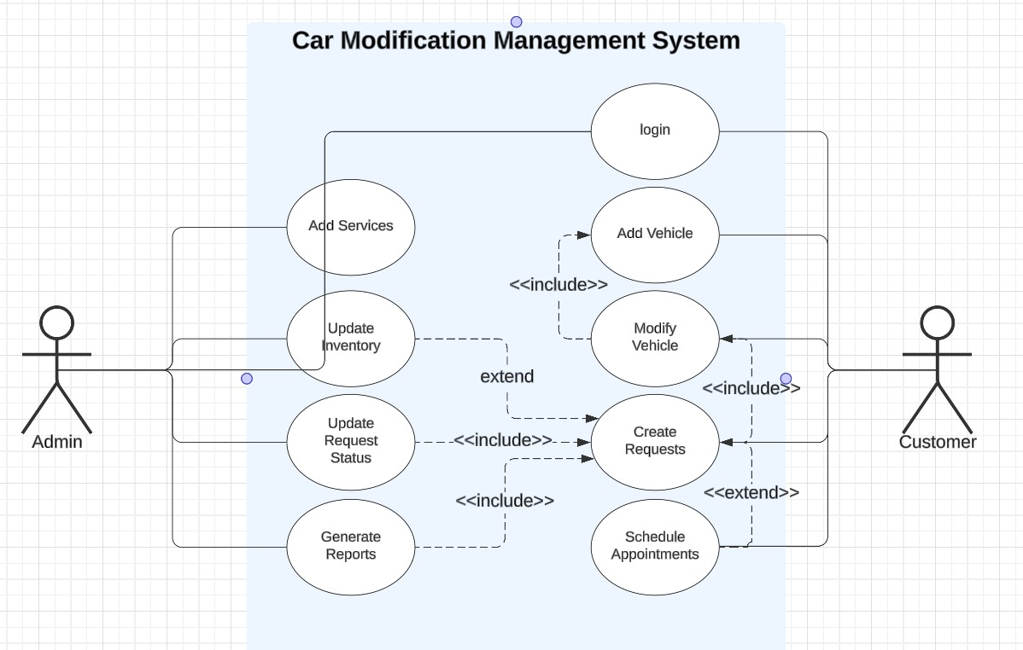

|  |  |
| --- | --- |
| **User case Name** | **Product Adding** |
| **Actors** | **Customer, Admin** |
| **Main Success scenario** | * **A customer browses available car modification products (e.g., performance parts, styling accessories, etc.).** * **The customer selects a desired product and clicks on the "Add to Cart" button.** * **The system validates the customer’s account status (active and paid, if required).** * **The system confirms the addition of the product to the cart and updates the customer’s shopping cart.** * **The customer proceeds to checkout to finalize the purchase.** |
| **Exceptions** | * **If the customer's account is inactive, the system displays a message and prompts them to activate the account.** * **If the product requires additional customization or payment, the system redirects the customer to the payment gateway or customization options.** * **If the product is out of stock, the system notifies the customer and suggests similar products.** * **If the system encounters an error during the process, a generic error message is displayed, and the customer is encouraged to contact support.** |
| **Actions** | * **Display a success message confirming the addition to the cart.** * **Update the cart with the selected product.** |
| **Pre-Condition** | **The customer must be logged into the system.** |
| **Post-Condition** | **The product is added to the cart, and the customer can proceed with the checkout.** |

**Use case 1: Product Adding**

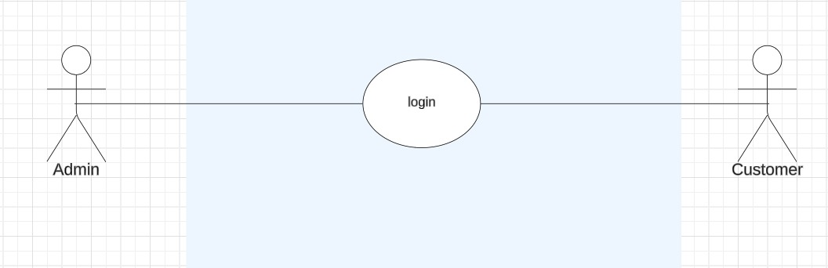

**Use case 2: login**

|  |  |
| --- | --- |
| **User case Name** | **Login** |
| **Actors** | **Customer and admin** |
| **Main Success scenario** | **1.**  **The system displays the login form.**  **2. The user enters their login credentials (email/username and password).**  **3. The system validates the credentials.**  **4. Upon successful validation, the system grants access to the user.**  **5.The user is redirected to their respective interface based on their role (Administrator or customer)..** |
| **Exceptions** | 1. **- Login Form Fails to Load:**    * **Display an error message: *"The login page failed to load. Please refresh the page or try again later."*** 2. **Incorrect Credentials:**    * **Notify the user: *"The username or password you entered is incorrect. Please try again."*** 3. **No Matching User Found:**    * **Display an error: *"We couldn’t find an account matching your details. Please check your username and password, or register for a new account."*** 4. **System Error During Login:**    * **Display a generic error: *"An unexpected error occurred. Please try again later."*** |
| **Actions** | **1. Administrator Dashboard: Access to manage inventory, users, and platform settings.**  **2. Student Dashboard: Access to cart, recommendations, and the shopping service.** |
| **Pre-Condition** | **1.The user has an existing registered account.**  **2.The user has not been banned or restricted from using the platform.** |
| **Post-Condition** | **1.The user is successfully logged into the system.**  **2.The user has access to their personalized dashboard and relevant features.** |

**Use case 3 : search Products**

|  |  |
| --- | --- |
| **User case Name** | **Search Products** |
| **Actors** | **Customer** |
| **Main Success scenario** | * **The customer selects “Search Products” from the menu or homepage.** * **The customer enters search criteria, such as product name, category (e.g., exhaust systems, body kits), or brand, and selects the desired price range or other filters.** * **The system displays a list of all the products that match the search criteria and indicates if any product is out of stock, showing the next available restock date.** |
| **Exceptions** | * **No Available Products: Display a message: "No products matching your search criteria are currently available. Please try different keywords or filters."** * **Error in Product Search: Notify the user: "An error occurred while searching for products. Please refresh the page or try again later."** * **Invalid Search Criteria: Display an error message: "Invalid search criteria. Please check your input and try again."** |
| **Actions** | **The system analyzes the provided search criteria and displays:**   * **Product names, descriptions, and brands** * **Availability (in stock or out of stock)** * **Price and shipping information** |
| **Pre-Condition** | **The user must be logged into the platform.**  **The platform should have an active list of products available for purchase.** |
| **Post-Condition** | **A list of products matching the search criteria is displayed.** |

**Use case 4: General Reports**

|  |  |
| --- | --- |
| **User case Name** | **Generate Sales Reports** |
| **Actors** | **admin** |
| **Main Success scenario** | * **The Admin accesses the reporting functionality within the e-commerce platform (e.g., sales reports, revenue reports, order history).** * **The Admin selects the specific report category to generate (e.g., total sales, revenue by category, top-selling products).** * **The system retrieves the relevant data based on the selected report category.** * **The system generates the report and displays the data in an organized format (e.g., tables, graphs).** * **The Admin reviews and analyzes the report, using it for financial or operational analysis.** |
| **Exceptions** | **Insufficient Data:**   * **If there is insufficient data to generate the report, the system will:**   + **Display a warning message: "Insufficient data available to generate the requested report. Please try adjusting the filters or parameters."**   + **Ask the Admin to modify the report parameters (e.g., changing the date range, filtering by specific product category).**   + **Provide alternative options for obtaining the desired report or suggest a different report that may have sufficient data.**   **Sufficient Data: If sufficient data is available, the report is generated automatically.** |
| **Actions** | * **The system generates the requested report, ensuring that the data is accurately retrieved and displayed in a useful format (e.g., charts, tables).** * **If the report is incomplete or there is insufficient data, the system guides the Admin to resolve the issue by adjusting parameters or selecting alternative reports.** |
| **Pre-Condition** | * **The Admin must have the necessary permissions or authorization to access the reporting feature.** * **The Admin should have the required data available in the system (e.g., sales data, customer data).** |
| **Post-Condition** | * **The requested report is generated and presented in a structured format.** * **The Admin can use the report for analysis, decision-making, or generating further insights into business operations.** |
|  |  |

## **5.2 Sequence diagram**

**5.3 Class diagram**

